**Extent of harappa civilization**

Archaeological excavation of excavation of an ancient Buddhist temple was conducted at Larkana district in Sind. During excavation, archaeologists discovered pre-historic clay-pots and a few pieces of artistic works made of stone. The ruins of a very old civilisation were beneath the ground wherein the actual excavation was being carried on. The name of the place was ‘Mohenjo-Daro’.

Archaeologistsfurther discovered in Harappa the same ruins of the civilisation as were found at Mohenjodaro. Harappa was in the Montgomery district of the Punjab and was 650 kilometers away from Mohenjodaro.

After 1947, governments of India and Pakistan took initiative to conduct excavations in more other places, and discovered relics of the Indus Civilization. It is found that the circumferential extension of the civilisation over the area was 1550 kilometers.

Even special and important ruins similar to those found at the Indus valley have been discovered in places far away from the areas near the river, Indus.

At Rangur, Lothal in Gujarat, and in some other places near the Nerboda, same traces as those at Harappa have been found. It is as if these areas bore witness to the transformation of Harappan civilisation. At Lothal, houses, streets and thorough fares, public baths, sewer systems, harbors far small ships, docks etc. have been unearthed in copies number. These deserve mention along with the relics of Mohenjodaro and Harappa.

# Important Sites of the Indus Valley Civilisation

**Harrapa**

Harappa is a large capital of the Indus Civilization, and one of the best-known sites in Pakistan, located on the bank of the Ravi River in central Punjab Province.

At the height of the Indus civilization, between 2600-1900 BC, Harappa was one of a handful of central places for thousands of cities and towns covering a million square kilometers (about 385,000 square miles) of territory in South Asia.

Harappa was occupied between about 3800 and 1500 BC: and, in fact, the modern city of Harappa is built atop some of its ruins. At its height, it covered an area of at least 100 ha (250 ac) and may have been about twice that, given that much of the site has been buried by the alluvial floods of the Ravi river.

**Mohenjo- Daro**

Mohenjo-daro is widely recognized as one of the most important early cities of South Asia and the Indus.

**Discovery and Major Excavations**

Mohenjo-daro was discovered in 1922 by R. D. Banerji, an officer of the Archaeological Survey of India, two years after major excavations had begun at Harappa, some 590 km to the north. Large-scale excavations were carried out at the site under the direction of John Marshall, K. N. Dikshit, Ernest Mackay, and numerous other directors through the 1930s.

Although the earlier excavations were not conducted using stratigraphic approaches or with the types of recording techniques employed by modern archaeologists they did produce a remarkable amount of information that is still being studied by scholars today.

**Alamgirpur**

Located in the Meerut district of Uttar Pradesh, Alamgirpur is the eastern most site of the Indus Valley Civilization. This site is located very near to the Hindon river.

Alamgirpur respectively belonged to (I) Harappan, (II) Painted Grey Ware (III) Early historical and (IV) Late Medieval Period.  
The site was partially excavated in 1958 and 1959 by Archaeological Survey of India. On excavation, the site showed four cultural periods with intervening breaks; the earliest of them represented by a thickness of 6 feet, belonged to the Harappan Culture.

Although kiln burnt bricks were in evidence, no structure of this period was found, probably due to the limited nature of the excavations. Brick sizes were, 11.25 to 11.75 in. in length,5.25 to 6.25 in. in breadth and 2.5 to 2.75 in.in thickness; larger bricks averaged 14 in. x 8 in.x 4 in. which were used in furnace only.

**Kalibangan**

The site Kalibangan – literally ‘black bangles’ – derives its name for the dense distribution of the fragments of black bangles which were found at the surface of its mounds.

Evidence of this period consists of a citadel area over the 1.6 metre-thick early Harappan deposit in Kalibangan-1 (the western mound of the site, a chessboard pattern ‘lower city’ in Kalibangan-2 (the lower and larger eastern mound), and a mound full of fire altars in a much smaller mound further east (Kalibangan-3).

The citadel complex of KLB-1 is roughly a parallelogram (240 by 120 metres) divided into two equal parts with a partition wall and surrounded by a rampart with bastions and salients. The basil width of the fortification wall is 3-7 metres.

**Kot Diji**

Kot Diji is an archaeological site located near an ancient flood channel of the Indus River in Pakistan, 15 miles (25 km) south of the city of Khairpur in Sindh province.

The site, which is adjacent to the modern town of Kot Diji, consists of a stone rubble wall, dating to about 3000BC, that surrounds a citadel and numerous residences, all of which were first excavated in the 1950s.

The origins of Kot Diji are recognized as belonging to the early Harappan period, which dates to about 3500BC. Although Kot Diji lasted through the mature Harappan period (about 2600–1750BCE), a layer of burned debris separates structures of the early and the mature periods, which suggests that the settlement was at some point heavily damaged by fire. Artifacts, including pottery, that display a distinct Kot Dijian style have been excavated from Kot Diji and other archaeological sites in the region.

**Lothal**

Lothal, literally “Mound of the Dead”, is the most extensively excavated site of the Harappan culture in India, and therefore allows the most insight into the story of the Indus Valley Civilization, its exuberant flight, and its tragic decay.

Once a sleepy pottery village, Lothal rumbled awake to become a flourishing centre of trade and industry, famous for its expertly constructed system of underground sanitary drainage, and an astonishing precision of standarized weights and measures.

Unlike many other doorways into Harappan culture, Lothal passed through all the phases of the society, from earliest development to most mature. In the height of its prosperity, it not only survived but was strengthened by three floods, using the disaster as an opportunity to improve on the infrastructure. The fourth flood finally brought the settlement to the desperate and impoverished conditions that indicated the end of a powerful civilization.

**Amri**

The archaeological importance of Amri was demonstrated in 1929 by the excavations of N.G.Majumdar, who discovered there, for the first time, a settlement of pre-Harappan date and culture that was underlying a Harappan one.

There are four successive periods of occupation. The first of these is the ‘Amrian’, which relates to other pre-Harappan sites in the region as well. Amri is the type-site of this early cultural assemblage. In this phase, houses were of mud-brick. Pottery, copper and bronze fragments were also recovered. Phase II shows an increasing component of Harappan materials alongside the Amrian. Period III belongs to the Harappan, giving evidence of early, transitional, and late sub-phases, into a final ‘Jhukar’ sub-phase. The final phase, Period IV, is not well represented, but it produced the coarse grey ware comparable to the sites of the ‘Jhangar’ complex.

**Chanhudaro**

Chanhudaro  (also Chanhu Daro) is an archaeological site belonging to the post-urban Jhukar phase of Indus valley civilization. The site is located 130 kilometers south of Mohenjo-daro. The settlement was inhabited between 4000 and 1700 BCE, and is considered to have been a centre for manufacturing carnelian beads. This site is a group of three low mounds that excavations have shown were parts of a single settlement, approximately 5 hectares in size.

**Rupar**

Rupar is another Indus Valley site. At Rupar excavation, the lowest levels have yielded the Harappan traits in Period 1, which falls in the proto-historic period. A major find has been a steatite seal in the Indus script used for the authentication of trading goods, impression of seal on a terracotta lump of burnt clay, chert blades, copper implements, terracotta beads and bangles and typical standardized pottery of Indus Valley Civilization. They flourished in all the Harappan cities and townships.

**Banawali**

Banawali is an archaeological site belonging to the Indus Valley Civilization period. It is in the Fatehabad district of Haryana and is located about 120 km northeast of Kalibangan.

In comparison with Kalibangan, which was a town established in the lower middle valley of the dried up Sarasvathi River, Banawali was built over the upper middle valley of Sarasvathi River.

Well planned houses were constructed out of kiln burnt and moulded bricks. Pottery consisting of vases and jars, and is divided into two groups, based on general design. Pottery assemblage is very similar to those of Kalibangan I period.

**Surkotada**

Surkotada is a small, 3.5 acre site northeast of Bhuj, in Gujarat. The mound has an average height of five-to-eight metres (east-to-west).

At the time of its discovery, the mound at Surkotada appeared to be a potential site with not only its available rubble fortifications exposed at places on the surface itself but also having an adjacent lower area yielding Harappan and other pottery and antiquities. The excavations at Surkotada have been significantly rewarding in unfolding a sequence of three cultural sub-periods well-within the span of Harappan chronology and this fact has been attested to by the C-14 dating, i.e. circa 2300 B.C. to 1700 B.C.

**Sutkagan Dor**

Sutkagan Dor (or Sutkagen Dor) is the westernmost known archaeological site of the Indus Valley Civilization. It is located about 480 km west of Karachi on the Makran coast, near the Iranian border, in Pakistan’s Baluchistan Province. The site is near the western bank of the Dasht River and its confluence with a smaller stream, known as the Gajo Kaur. It was a smaller settlement with substantial stone walls and gateways.

Sutkagan Dor was discovered in 1875 by Major Edward Mockler, who conducted a small-scale excavation.

Harrapan town planning

* The orientation of streets and buildings, according to the cardinal directions east-west, and north-south was the distinguishing factor of the *Indus-Saraswati* cities.

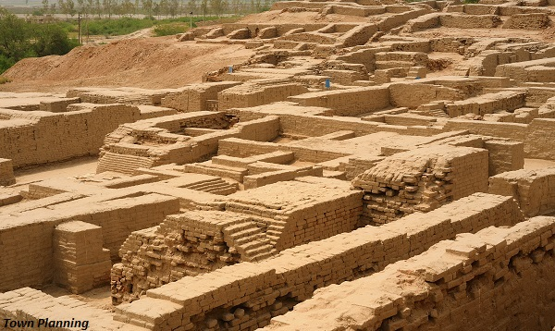

* *Harappan* city sites, including *Mohenjo Daro, Harappa, Kalibangan,* and *Surkotada* were having large gateways at various entry points of the city. These gateways are seen even in the inner fortification areas also.
* At *Dholavira*, a fallen signboard was found close to the main gateway. It is a large inscription having ten symbols each measuring approximately 37 cm high and 25 to 27 cm wide proclaimed some name or title.

## **Materials Used in Buildings**

* Most settlements were situated in the alluvial plains where the most common building materials were mud-bricks and kiln-fired-bricks, wood and reeds.
* In the foothills and on the Islands of Kutch and in Saurashtra, dressed stone replaced bricks (due to an abundance of stone).
* The sizes of bricks have been found identical proportions 1:2:4, that the width is double the thickness and the length four times, the thickness.
* Doors and windows were made up of wood and mats.
* Floors of houses were generally hard-packed earth that was often plastered.
* Drains and bathing areas were made with baked bricks or stone.
* Roofs were probably made of wooden beams covered with reeds and packed clay.

## **Types of Buildings**

* Excavations have uncovered many types of houses and public buildings at both large and small settlements.
* The architecture may be grouped into three categories with some variations as −
  + Private houses,
  + Large houses surrounded by smaller units, and
  + Large public structures.
* Doorways and windows rarely opened out into the main street, but faced side lanes.
* The view into the house was blocked by a wall or a room around the front door. This was done to protect the activities in the central courtyard from the view of passers-by.
* The doors were made with wooden frames and a brick socket set in the threshold served as door pivot.
* Some of the doors seem to have been painted and possibly carved with simple ornamentation
* The windows were small at first and second stories.
* The adjacent houses were separated by a narrow space of "no man's land".

### **Public Buildings**

* Some large and distinct structures have been found in several cities designed especially for the public purpose.

## **Great Bath of Mohenjo Daro**

* The Great Bath of *Mohenjo Daro* is the most remarkable feature of any *Harappan* site.
* The Great Bath was a brick structure, which measured 12 m by 7 m and is nearly 3 m deep from the surrounding pavement.
* Water was evidently supplied by 3 large well placed in an adjacent room.
* Surrounding the bath, there were porticos and sets of rooms, while a stairway led to an upper storey.
* The bath was linked with some sort of ritual bathing, which was very common in Indian life right from the ancient times to till date.
* Immediately to the west of the Great Bath (at *Mohenjo Daro*) was a group of 27 blocks of brickwork crisscrossed by narrow lanes. This structure measures 50 m. east-west and 27 m. north-south. These structures have been identified as granaries, which were used for storing grains. Similar structures have been also found at *Harappa, Kalibangan,* and *Lothal*.
* The dockyard found at Lothal was another important structure. It was a large structure measuring 223 m. in length, 35 m. in width and 8 m. in depth, provided with an inlet channel (12.30 m. wide) in the eastern wall and a spillway.

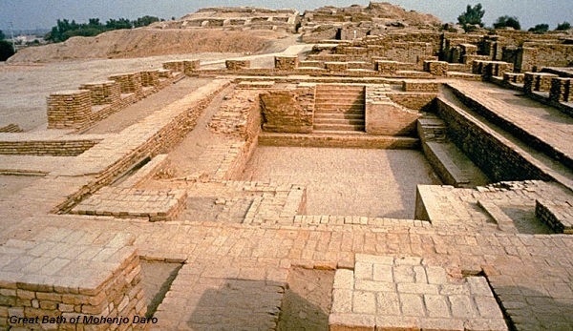

* The inlet channel was connected to a river. By its side, it was 240 m. long and 21.6 m wide wharf. This was a dockyard where ships and boats used to come for loading and unloading of trading goods.
* *Lothal* was a major trading center of the *Harappan* civilization.

## **Streets and Drains**

* The most outstanding features of the *Harappan* civilization were the streets and side lanes equipped with drains system.
* The *Harappan* civilization is referred to as a Bronze Age civilization.
* Customarily, unalloyed copper was used for manufacturing artifacts and rarely tin was mixed with copper to make bronze.

## **Trade and Commerce**

* Intensive agricultural production and large-scale trade played significant roles in flourishing of the *Harappan* civilization.
* The elegant social structure and the standard of living must have been achieved by a highly developed system of communication and a strong economy.
* The trade must have been internal in the beginning i.e. between one zone and another.
* Agricultural produce, industrial raw materials (including copper ores, stone, semi-precious shells, etc.) were traded on a large scale.
* Besides the raw material, they used to trade −
  + Finished products of metals (pots and pans, weapon, etc.);
  + Precious and semi-precious stones (beads, pendants, amulets, etc.); and
  + Ornaments of gold and silver were also traded to various areas.
* They procured −
  + Copper from *Khetri* mines of Rajasthan;
  + Chert blades from *Rohri* hills of Sindh;
  + Carnelian beads from Gujarat and Sindh;
  + Lead from south India;
  + Lapis-lazuli from Kashmir and Afghanistan;
  + Turquoise and jade from central Asia or Iran;
  + Amethyst from Maharashtra; and
  + Agate, chalcedony, and carnelian from *Saurashtra*.
* The occurrence of mature *Harappan* seals and other artefacts in contemporary Mesopotamian civilization, and some of the Mesopotamian and Egyptian objects in *Harappan* civilization, and the evidence of Mesopotamian documents established that the *Harappans* had the trading relationship with each other.

## **Transport and Travel**

* Pictures of ships and boats are found on some seals and drawings on pottery from *Harappa* and *Mohenjo Daro*.
* Ship or a boat, with a stick-impressed socket for the mast, has been found from Lothal.
* The boats depicted on seals and pottery resembles with the boats used in Sindh and Punjab areas (even today).
* For land transport, bullock-carts and pack animals like bull, camel, ass etc. were used.
* The terracotta models of bullock-cart found on roads from various sites indicate that carts used in those days were of the same size and shape used in the present day.

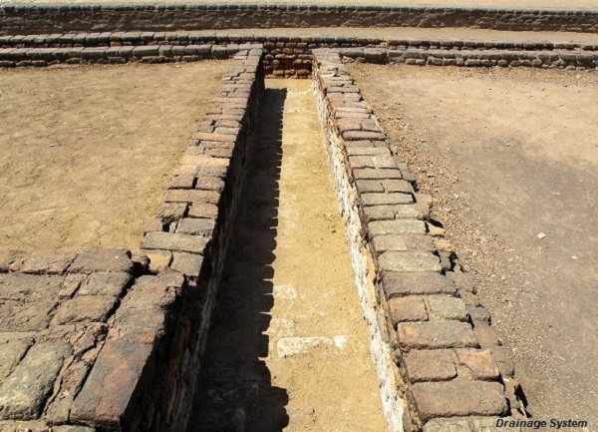

* The streets cut each other on the right angles and the width of these streets was in a set ratio.
* No encroachment on the streets was to be seen.
* Even smaller towns and villages had impressive drainage systems. This indicates that people had a great civic sense of sanitation and care for health and hygiene.
* Burnt bricks were used to make drains. Small drains connected with bathing platforms and latrines of private houses were joined with the medium sized drains in the side streets then these drains ran into larger sewers in the main streets which were covered with bricks or dressed stone blocks.

## **Arts**

* A large variety of objects such as seals, stone statues, terracotta, etc. is superb examples of the art activities.
* A *Yogi* from *Mohenjo Daro* and two small figurines from *Harappa* are the most outstanding pieces of art.

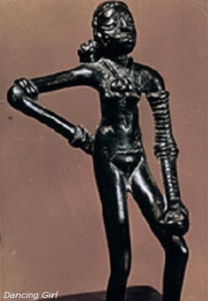

* A dancing girl statue of about 11.5 cm. in height made up of bronzes was found from *Mohenjo Daro*.
* *Daimabad* bronze animals’ workmanship, most likely belong to *Harappan* period.
* The red sandstone torso found at Harappa is made up of **detachable limbs and head.**
* The grey stone torso perhaps illustrates a dancing figure. Both these are so **realistic** that none would believe that they belong to the *Harappan* period.
* *Harappan* people produced a large number of terracotta figurines, which were handmade. The figurines include humans, animals, birds, and monkey.
* Following are the Specimen of Arts from the *Harappan* Civilization −
  + Bronze statue (Dancing Girl);
  + Terracotta Bulls;
  + Terracotta Female Figurine;
  + Head of a Yogi; and
  + Painted Jar dogs, sheep, and cattle.
* The most artistic depictions are the figures of humped bull. Figurines of both humped and humpless bulls are found in excavations
* A painting was found only on pottery. Unfortunately, no wall paintings, even if there were any, have survived.

## **Agriculture**

* Agriculture was generally practiced along the river banks most of which were flooded during the summer and monsoons. The flood deposited every year fresh alluvial silt, which is highly productive and for which no major furrowing and certainly no manures and irrigation were required.
* The cultivated field excavated at *Kalibangan* shows crisscross furrow marks indicating that two crops were grown simultaneously. This method is followed even today in the Rajasthan, Haryana, and western Uttar Pradesh.
* The granaries found at *Harappan* cities suggest that cereals were produced in such a large quantities. They also kept enough reserve to face any future emergency.
* The principal cereals were wheat and barley. Rice was also known and was a favored grain. Remains of rice have been found from Gujarat and Haryana areas.
* Six varieties of millets including *ragi, kodon, sanwa,* and *jowar* were cultivated, along with peas and beans.
* Fragments of cotton cloth found at *Mohenjo Daro* and other sites show that cotton was also grown.
* Cotton has been found at *Mehrgarh* at least 2,000 years before the mature phase of the Civilization. This is the oldest evidence of cotton in the world.
* Other major crops include dates, varieties of legumes, sesame, and mustard.
* Wooden plough with a copper or wooden ploughshare was used for tilling fields.
* Terracotta models of the plough have been found at *Mohenjo Daro* and *Banawali*.
* Harvesting of crops would have been done with copper sickles as well as stone blades hafted in wood.
* Animals like sheep, goat, humped bull, buffalo, elephant, etc. have been depicted on the seals. This shows that the range of animals domesticated by the *Harappan* people was quite large.
* Skeletal remains of several animals like sheep, goat, bull, buffalo, elephant, camel, pig, dog, and cat etc. have been found in excavations.
* Wild animals were hunted for the food. Bones of animals like spotted deer, sambhar deer, hog deer, wild pig, etc. found in the excavation prove it. Besides, several types of birds as well as fishes, were also hunted for food.
* Bones of horses have been reported from *Lothal, Surkotada, Kalibangan,* and several other sites.
* Terracotta figurines of the horse have been found at *Nausharo* and *Lothal*. But this animal is not depicted on seals.
* There are generally two aspects of Harappan religion −
  + Conceptual or philosophical and
  + Practical or ritualistic.

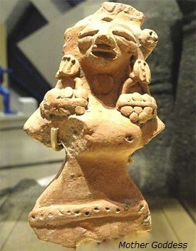

* The available evidence indicates that the religion of the Indus people comprised of −
  + Worship of the Mother Goddess;
  + Worship of a male deity, probably of Lord Siva;
  + Worship of animals, nature, semi human, or fabulous;
  + Worship of trees in their natural state or of their indwelling spirits;
  + Worship of inanimate stones or other objects, of *linga* and *yoni* symbol;
  + Chrematheism as illustrated in the worship of the sacred "incense-burners";
  + Faith in amulets and charms indicative of demonophobia; and
  + Practice of yoga.
* These characteristics suggest that the religion was mainly of an indigenous growth and "the lineal progenitor of Hinduism,” which is characterized by most of the features.
* A large number of female figurines of terracotta have been found, which are the representations of the Great Mother Goddess.
* A striking rectangle sealing found at *Harappa* represents the Earth or Mother Goddess with a plant growing from her womb.
* A male deity, which depiction Siva as *Pasupati* (i.e. the prototype of the historic Siva), is portrayed on a seal with three faces, seated on a low throne in the typical posture of a Yogi, with two animals on each side - elephant and tiger on right and rhinoceros and buffalo on left, and two deer standing under the throne.
* A terracotta piece having *linga* and *yoni* in one piece found from *Kalibangan*. People of Kalibangan region were worshiped the symbolic representation of *Siva* and *Sakti* respectively.
* A remarkable seal, found at *Mohenjo Daro*, standing between two branches of a *pipal* tree, represents the deity.
* A large number of 'fire-altars' have been found from the sites located in Gujarat, Rajasthan, and Haryana. From *Kalibangan, Lothal,* and *Banawali* a number of 'fire-altars' have been found.
* *Swastika*, a sacred symbol with Hindus, Buddhists, and Jaina has been depicted on seals, painting, and graffiti.
* A large number of terracotta figurines depict the individuals in various yogic postures (*asanas*) indicating thereby that the *Harappans* practiced yoga.

ARryan attack

The Harappan Civilization or the Indus Valley Civilization was the most fascinating and first urban civilization in the world that flourished in the vast plains created by the River Indus and its tributaries. The Harappan Civilization thrived between 2600 – 1900 BC in the region that is now in Pakistan and India. With the population of over five million, this civilization had a well developed trade system, cities, sewerage system, metallurgy techniques with many other mathematical and scientific achievements.

But with time, there was shrinkage in the Harappan Civilization. For instance, Mohenjodaro, one of the major cities of this civilization, earlier flourished on about eighty five hectares of land but later on got confined to just three hectares. Due to some reason, population from the Harappa started moving to the nearby and outer cities and places like Punjab, Upper Doab, Haryana, etc. But what leads to the decline of the Harappan Civilization is still a mystery.

**Proposed theories regarding the decline of the Harappan Civilization**

Definite reason that led to the decline of the Indus Valley Civilization is not known, as no reliable resource of that period is available at present. Every conclusion regarding the decline is based upon speculations of historians. Though the reason of the decline is not known, but through excavations it is clear that fall of the Harappan Civilization occurred between 1800 BC to 1700 BC.

It is commonly believed that the Aryans were the next settlers. They were skilled fighters, so their attack might have led to the destruction of the Harappan Civilization. Even the epics of the Aryans mentioned about their victory over the great cities. The human remains found during excavation of Indus valley point towards some violent cause of their death. Now many historians, who do not believe this theory, say that the Aryans might not be involved in any such attack.

Owing to this conflict, the theory of a huge climatic change or natural disaster gained credibility. It has been found out that around 2000 BC some major climatic changes started occurring in the Indus Valley. These changes had led to floods in the plains and cities. Historians have found evidence to prove this theory as well. Most of the cities in the Harappan Civilization have been found in a condition as if these had been first abandoned and then rebuilt.

Cities, for instance, were initially built with great care but reconstruction of the same was done with broken bricks and no attention was paid to the proper sewage system during reconstruction. Proper sewage system was one of the major characteristics of the Indus Valley Civilization.

Then, there was a fall in the average rainfall in the cities leading to the formation of desert-like condition. This led to the decline in agriculture on which most of the trade was dependent. Owing to this, people of the Indus Valley started shifting to some other location leading to the decline in the entire civilization. As per some scholars, the reason of the decline is the change in the course of River Ghaggar-Harka that had led to an increase in aridity of the place. Around 2000 BC, there was found an increase in arid conditions. The location where the Indus valley civilisation once flourished is a desert today.

Many theories have been formulated and provided, but all the theories met with one or another form of criticism. Archeological evidences do prove that there was no sudden collapse of the Indus Valley Civilization but it declined over a period of time and got mingled with other civilizations of that period.

The succession of rise and fall is a law of nature. After 1500 years of prominence, the Harappan culture gradually declined to the point of extinction. Harappa, Mohenjo-Daro, Kalibangan and other centres of Harappan culture were no exception.

**The decline of Harappan culture has evoked the historians to find out its causes.**

#### 1. Law of Nature:

Renowned historian Arnold Joseph Toynbee has categorized the decay of a culture as its final stage after a culture is born and grows to its highest point of efficacy. The Harappan culture was no exception to this general law of nature. Its decline set in around 1800 B.C. and in course of time came its extinction.

#### 2. Floods:

ADVERTISEMENTS:

The massive floods in the Indus must have been a potent cause for the extinction of the Harappan culture. The point is proved by the silt-clay that covers the collapsed houses at Mohenjo-Daro. Repeated floods must have forced the people to flee the inundated places and set up permanent habitat elsewhere. As a consequence came the decline of Harappa.

#### 3. Earthquakes:

Geographically, the Harappan culture occupied an area that was prone to earthquakes as it came under a seismographic zone. Repeated seismographic vibrations must have led to erosion that brought down the buildings. Earthquakes constitute an important reason for the decline of Harappan culture.

#### 4. Change of the Course of the Indus:

Some Historians attribute the decline of the Harappan culture to the river Indus changing its course frequently. As such the Indus delta shifted away from Mohenjo-Daro and water became scarce. Water scarcity must have led to the exodus of the Harappan people to other places. Yet, the change of course of the Indus is not reason enough for the decline in Lothal, Kalibangan, Rupar etc. because the Mohenjo-Daro situation did not occur in these regions.

#### 5. Plague:

Outbreak of the plague epidemic is shown as a reason for the decline of Harappan civilization. Skeletal remains from the main roads of Harappa and Mohenjo-Daro as found out through archaeological efforts tell a sad story. When an epidemic like plague visits a human habitation, it leaves its trail of death everywhere. The scattered skeletal remains therefore lead some to attribute it to epidemic like plague, though there is no concrete proof of outbreak of plague in the region.

#### 6. Foreign Invasion:

ADVERTISEMENTS:

Sir Mortimer Wheeler however is of the opinion that the Aryan invasion is the reason for the decline of Harappan culture. There is archaeological proof of genocide and unburied skeletal remains scattered everywhere in Mohenjo-Daro. An autopsy on these skeletons reveals damages that must have been caused by sharp objects or weapons. Knowledge and use of iron as weapons was known to the Aryans, not to the Harappan people. Defeat and death of the Harapan people must have come at the hands of the invading Aryans.

The Aryan cavalry must have been an adverse point for the Harappans who did not know the use of horses. Prof D.D. Kosambi holds this view also. Further, the Vedas speak of the forest of the ‘dasa’ or ‘dasyu’. The god Indra of the Vedas is also known as Purandara or destroyer of the forts.

The view of Kosambi is fairly acceptable in the context of the forts of the Harappan culture. Areas of Harappan culture which were not invaded by the Aryans might have perished due to barbaric conflicts with rural and forest people. Anyway, foreign invasion goes a long way to account for the decline of the Harappan culture.

The multiple causes, enumerated above, were responsible for the decline of Harappan culture. Thanks to archaeological efforts, we now know a lot about this oldest urban culture of India. Indeed their town-planning, social and religious life, the Lothal port, the unique art and architecture, artifacts and pottery have led everybody to look upon them with awe and admiration.

ADVERTISEMENTS:

India and the world marvels at the wonder of Harappan culture. Yet, this culture could not defeat the law of nature and was, as such, not imperishable. Most of the rich traditions left behind were later on retained by the Aryans and others.